**PERIOD PARAMETERS**

To create a payroll we need to get period parameters

A period parameter is a two digit numeric parameter that determines the interval for which payroll has to runfor a specific payroll area.

CONFIGURATION:

SPRO►Refimg►payroll►goto particular country(India)(40)►Basic settings►payroll organization

1.Define period parameters:

We can create our own period parameters using time units these are monthly, semi-monthly, weekly, bi weekly, Annually, quarterly, every four weeks, half yearly

We can use any two-digit number for period parameters 01 - 99 no restrictions

Period parameter =95

Name = 24SEP PP

Time unit=01

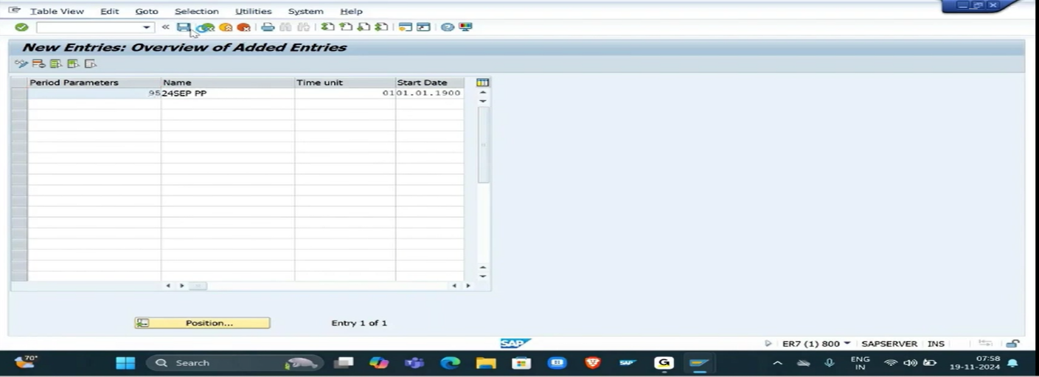

2.Check Payroll Accounting Area

Payroll area =S4

Payrollarea text =24SEP payrollarea

Period parameters =95

Select the checkbox to run payroll

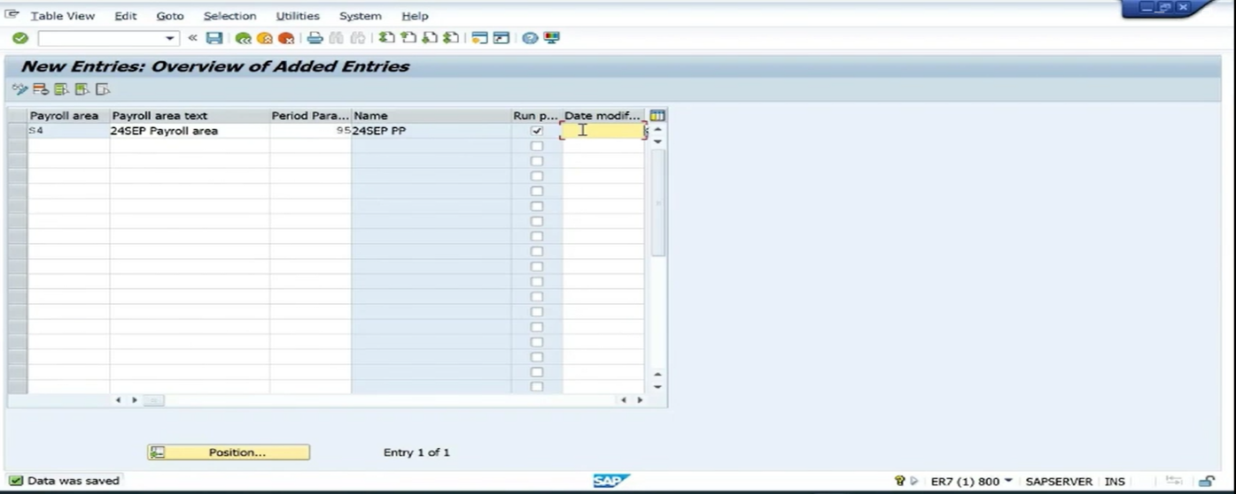

Date modifer(v_T549A) =01

If there is a differ in the payment date we use the date modifier.

3.Generate payroll periods.

Period parameters =95, start date=01.01.2018(take atleast 4-5 years back dates), final year=2030,start date of fiscal year=04.01, payday rule=03, first go for a testrun then execute liverun.

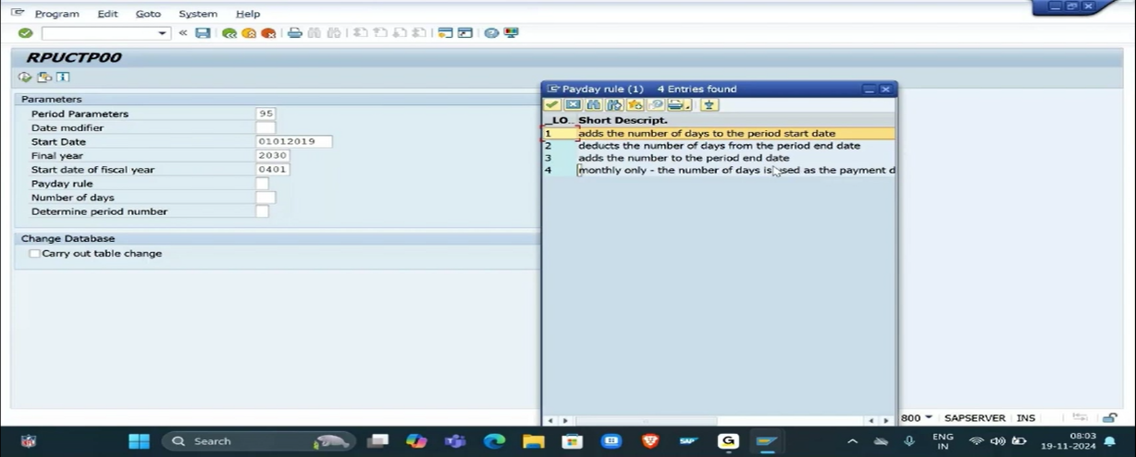

4.V_T549Q (PAYROLL PERIODS)

We can check that all the payroll periods are stored here when we enter our period parameter and payroll year we can check pay periods here

The first payperiod must be April and last payperiod must be March.

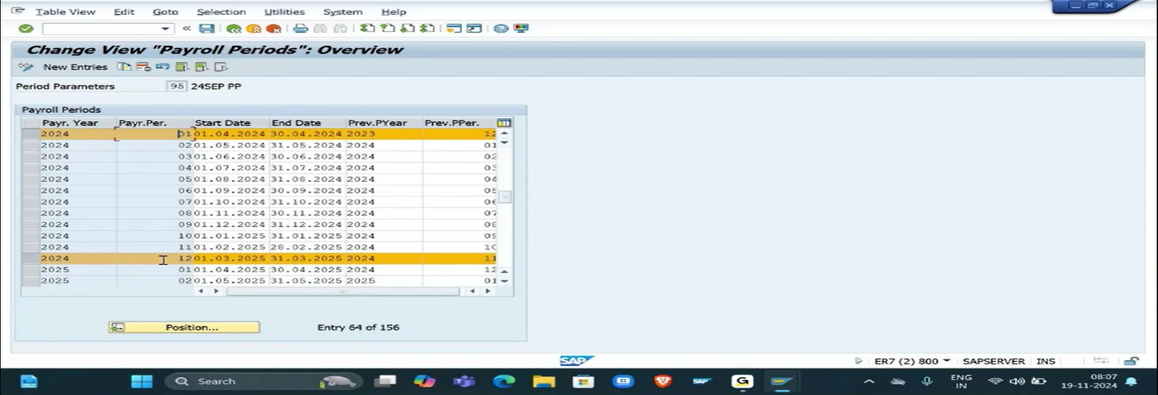

5.V_T549S(PAYMENT DATE)

Go to position give period paraameter=95, payroll year=2024, we can check here the payment dates of the particular months of that year

We can also change the payment date manually if the date falls on a public holiday or weekoff ( it should be made every year manually ,it is a year ending activity).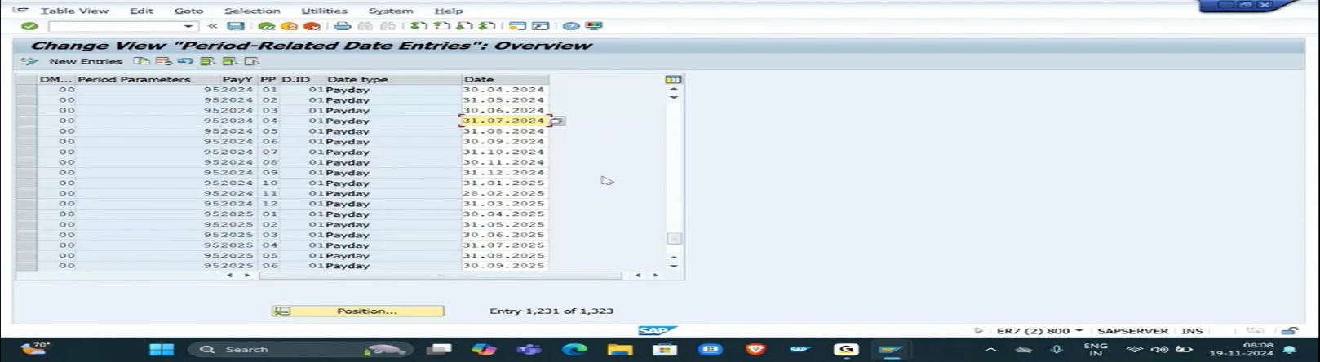

6. Payroll Control Record (PA03)

Each payroll is associated with one control record ,defines the current payroll periods and the previous payroll periods for retroactive accounting.

Payroll area =S4 ( we are creating control record for this payroll area)

We want to run the payroll for 1 april , always give 12 2023 as start year because of cutoff date for april 2024

In the earliest retroactive period give same date 12 2023 save the record

Click release for payroll it automaticlly jumps to the next pay period

Go back and enter release for correction to make changes in the employee master data and enter our payroll period

PA30 give employee id and select org Assignment click change and enter S4 under payroll area,save the record.

Now click release for payroll and update same under PA30

Goto pe03 and click release for correction and save the record make changes for PSA =0002 if neeed

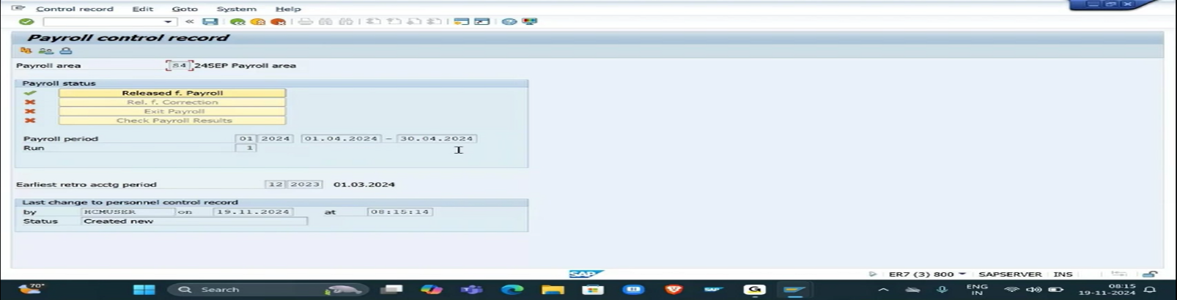

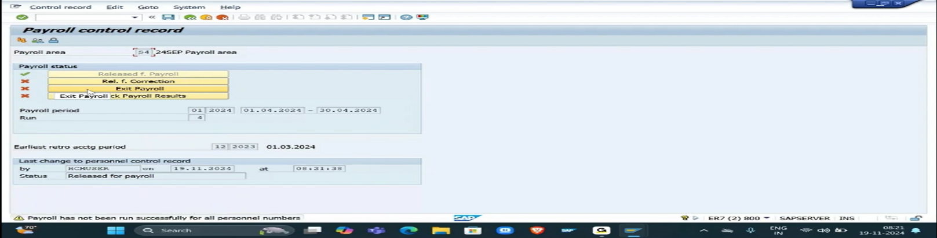

7.Exitpayroll:

Once we click exitpayroll we can exit from particular pay period jumps for next month for payroll,then enter release for payroll

(it was done after payroll periods &payment date was done tonshift next year)

8.Check payroll results

Employee gross salary/Net salary,taxes,deductions,exumptions we can see here in check payroll results.